www.seesaw.me (don’t search the app stores!)
1

Scroll down
(A lot!)
Scroll
down

2

3

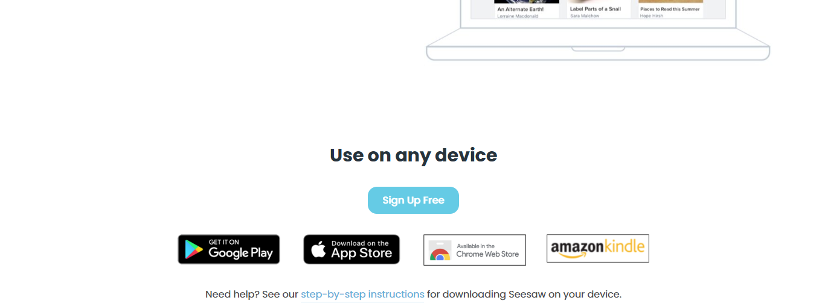
Download the app you need

