Now They Are Growing Up ……
(What young people need to know)

A Series of Information Booklets for Parents On:

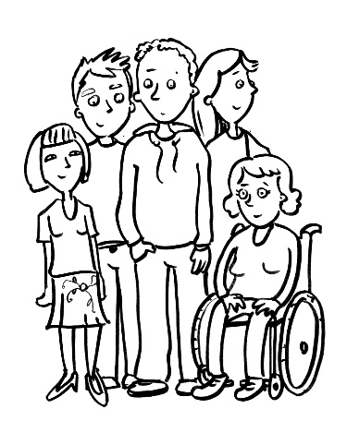
- Menstruation
- Male Masturbation
- Female Masturbation
- HIV & AIDS
- Protecting Your Child
- A Planned Dependent Life & Sexuality
- Loss (also suitable for younger children)
- Smearing
- Your Child’s Right (an introduction to Sex
Education for parents)
- Your Child’s Right 2 - FAQ

Booklets for Young People on:
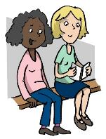
‘Feeling Grown Up’

- Female Masturbation
- Male Masturbation
- Menstruation at Home
- Menstruation at School
- Wet Dreams
- Use of Public Toilets
- Sexting
- Internet Dating

ALL BOOKLETS £3.00 each plus postage & packaging

For further information and purchase, please contact:
Oak Field School, Wigman Road, Bilborough
Nottingham, NG8 3HW
Tel: 0115 915 3265
Email: admin@oakfield.nottingham.sch.uk
OAK FIELD SCHOOL
ORDER FORM
‘NOW THEY ARE GROWING UP …’
(What Young People Need to Know)

Name: ………………………………………………………………………………………………………….

Address: ………………………………………………………………………………………………………

……………………………………………………………………………………………………………………….

……………………………………………………………………………………………………………………….

Contact Name: ……………………………………………………………………………………………

Telephone Number: …………………………………………………………………………………..

Official Order No. (if applicable): ………………………………………………………..

□ A cheque is enclosed in full payment and the cheque has been made payable to OAK FIELD SCHOOL.

□ Please accept my order and send an invoice with the booklets for my attention.

Signed: …………………………………………………………………………………………………………

Dated: ………………………………………………………………………………………………………….

For further information please contact:
Oak Field School, Wigman Road, Bilborough
Nottingham, NG8 3HW
Tel: 0115 915 3265
Email: admin@oakfield.nottingham.sch.uk
www.oakfieldschool.org.uk
OAK FIELD SCHOOL

Order Form
‘Now They Are Growing Up …’
(What Young People Need to Know)

Information Booklets for Parents
Title | Cost  £ | Quantity | Total Cost
Male Masturbation | 3.00
Female Masturbation | 3.00
Protecting Your Child | 3.00
Menstruation | 3.00
Planned Dependent Life & Sexuality | 3.00
Hiv & Aids | 3.00
Loss | 3.00
Smearing | 3.00
Your Child’s Right | 3.00
Your Child’s Right 2 - Faq | 3.00
Booklets For Young People
Female Masturbation | 3.00
Male Masturbation | 3.00
Menstruation At Home | 3.00
Menstruation At School | 3.00
Wet Dreams | 3.00
Public Toilets | 3.00
Sexting | 3.00
Internet Dating | 3.00
Postage & Packaging
Postage & Packaging 1-7 Booklets | 2.00
Postage & Packaging 8 – 15 Booklets | 2.50
Postage & Packaging 16 – 25 Booklets | 3.00
Postage & Packaging 25 & Over | 4.00
TOTAL AMOUNT |  |  | £

