Oak Field Occupational Therapy Team

Dressing advice - Fastening buttons

Introduction

Fastening and unfastening buttons are complex skills for children to learn. They need to have mastered physical skills with two handed co-ordination, fine finger control and in-hand manipulation.
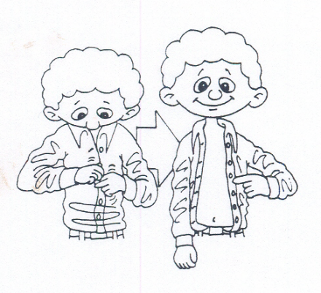

Strategies to help develop independence with buttons

- Ensure that your child is in a comfortable and stable position. It might be easier for them to sit on a chair with their feet supported.

- Practice pincer grasp and finger awareness activities:
  - Place small pegs into a board.
  - Place coins into a moneybox.
  - Touch each fingertip to the thumb of the same hand in sequence. Practice rolling a coin between finger and thumb.

- Practice bilateral activities (two handed activities) involving both hands simultaneously doing different actions:

E.g. Threading 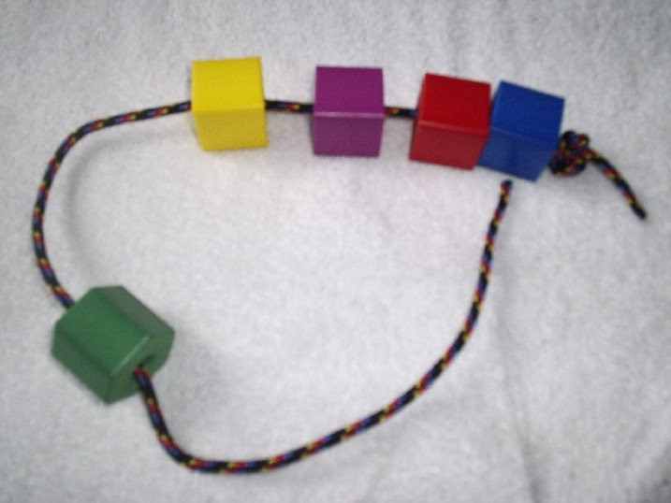
Winding thread onto a bobbin.
Folding, Tearing or cutting paper

- Practice doing large buttons initially on items that your child is not wearing.
Brightly colored buttons might be easier for your child to see.

- Once your child has mastered this progress to large buttons on dressing up clothes that your child is wearing.

- Gradually decrease the size of the buttons.

- Use a backward chaining approach to help your child to gradually increase his/her independence. Initially encourage your child to pull a halfway removed button from his/her buttonhole and gradually work backwards until he/she can do the whole procedure.

- Talk your child through the process with specific prompts of where to hold the button and clothing. It may help if you slowly demonstrate it to your child, sat at his/her side.

- It is important that your child is given regular opportunity to practice but that this is kept as pressure free as possible. Evenings and weekends are likely to be a better time to practice than when rushing for school in the morning.

