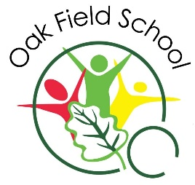


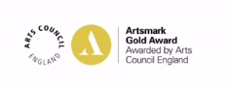
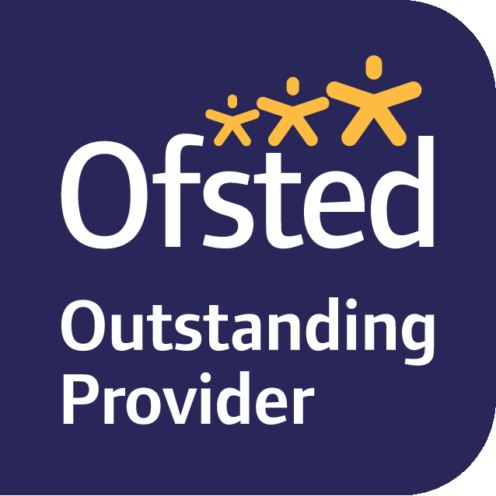


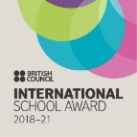

Oak Field School
Head Teacher: Ms Patricia Lewis BA Hons (Cantab) MA (Cantab) PGCE PGCSE
Wigman Road, Bilborough, Nottingham. NG8 3HW
Tel: 0115 915 3265 Fax: 0115 915 3264
Physio/OT Tel: 0115 952 2417 Speech & Language Tel: 0115 952 2418
e:admin@oakfield.nottingham.sch.uk w: www.oakfieldschool.org.uk
‘Life itself is the groundwork of education and training’

Maintained by
Nottingham City Council

Friday 11th June 2021
Hello Families,

You might remember that we offered ‘DfE’ tablet computers for loan during the pandemic. Pupils and their families had mixed responses to how useful these tablets were – they were heavily restricted in line with the government scheme.

We have since had them all reset and loaded with our special school owned software and games. Would you like to try again with a tablet device over the Summer Holiday? We can renew the ‘loan’ in September.

Software titles include:
Switch Skills 1, 2, 3
Big Bang patterns
Choose and Cook
Choose and Tell legends
Choose It Ready Made
Choose It Maker 2
Jigsaw Maker 2
Hygiene extra
Catchy Orbit
Feed Me
Switch skills Champions
Switch It!
Hygiene extra
Switch It! Maker

As well as a standard browser and Microsoft Office.

The tablets have child focused internet filtering, for peace of mind.

Please can you reply to the SMS if you would like to put your child’s name on the list for having a loan device over the Summer.

Thank you

Matthew Riley
Deputy Head Teacher

