
Feel the Beat
Today we’re going to explore the steady beat of music, the tempo (fast/slow).
We are going to listen to the sounds and feel the tempo of the beats on our bodies.
You will need 2-3 different songs to listen to with different instruments and different tempo’s.

Listen carefully, can you feel the beat in the music. Maybe you can tap your fingers or feel your grown-ups tapping on your thighs.
Do you like a slow tempo or a fast tempo?


What music do you enjoy listening too?
Maybe Jazz, Pop, Rock, Classical, Country. Let us know what you enjoy the most.

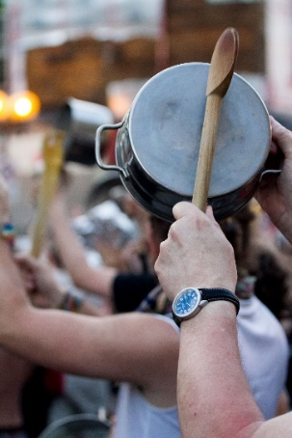
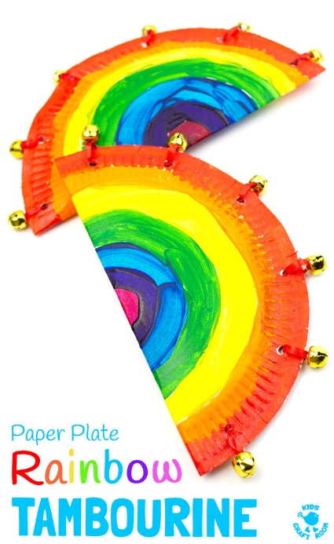
Can you find objects around your home to use as an instrument?
Have fun finding out what you like best!

