
Firework Sounds Activities
- Explore the sounds
- If you can, watch a video of fireworks on YouTube. Encourage listening to the noises, and looking at how the fireworks shoot into the sky. Introduce the Makaton sign for fireworks.
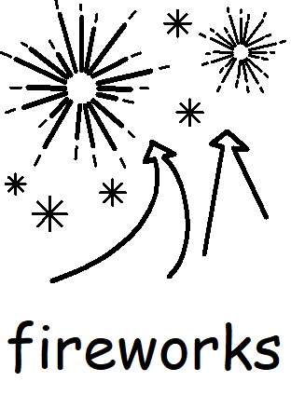
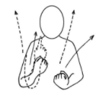

- Use the grid of images and words. Model pointing to each word/ image on the grid. As you point, make the noise that is written.

- Now ask your child to point to the words and make the sound that they point to. If they can, encourage them to make the noises too.

- If your child uses eye gaze, point to each picture and ask them to indicate ‘yes’ when it is the one they want.

- Create a poem
- When familiar with the sounds, choose their favourites and stick them onto the poem sheet.

- Read this poem to your child. Emphasise the sounds and the rhythm of the poem.

- Can your child join in with the poem by pointing to each word you say? Can they make some of the noises? Can they move their body in time with the rhythm? Can they make actions for each noise?

- Perform
- Perform your poem together. If you want, you could record it and send it to the school admin email address for school staff to see!

