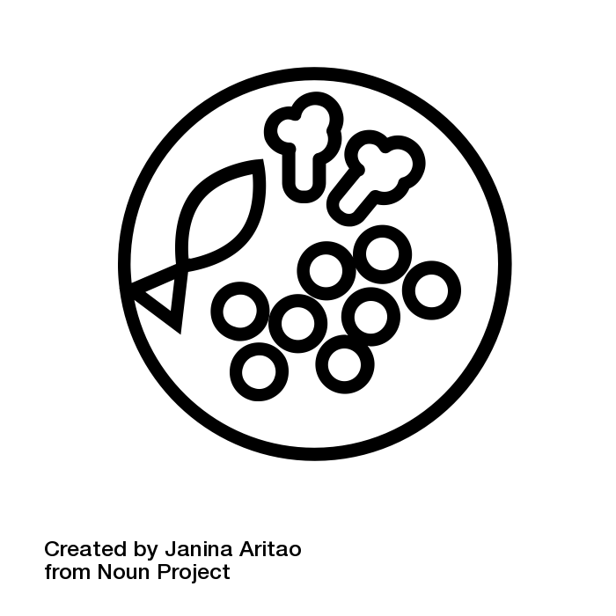
Free School Meals and school clothing allowance
Should I complete the application form?

Do not complete the form if:
- you receive Working Tax Credit you cannot receive Free School Meal Allowance
- you receive Universal Credit and your take-home pay is more than £616.67 per month

If you are receiving any of the following benefits, please complete the form:
- Income Support
- Income Based Job Seekers Allowance
- Income Related Employment Support Allowance
- A guarantee element of a Pension Credit
- Asylum Seeker support (under section 95)
- Child Tax Credit, with no Working Tax Credit, with an annual income of £16,190 or below (as assessed by HMRC)

You should also complete the form if you are:

- Asylum seekers reliant on ‘Section 4 support’ from the Home Office
- Granted leave to remain as ‘Zambrano carers’
- Granted leave to remain under Article 8 of the European Convention on Human Rights
- Supported under section 17 Children Act 1989 and who have ‘no recourse to public funds’.

