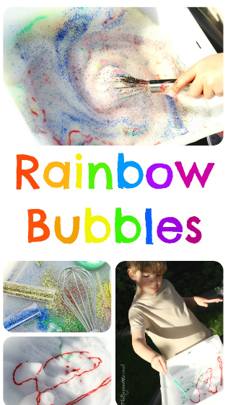
Rainbow bubbles:
You will need:
A shallow box, bowl or tray
Bubble Mix
A whisk
Glitter
Watered down paint

What to do:
- Pour bubble mix into a tray or bowl to a depth of at least 2 inches. It needs to be deeper to be able to be whisked. You could use water and washing liquid if you do not have bubble mix.
- Use a whisk with help to froth up the bubble mix – you could use a hand held or electric one. It takes a while to get lots of bubbles but this makes the next part more fun.
- Add glitter or watered down paint to the froth and stir to make a rainbow effect. You could add sequins or craft items to see what floats or sinks into the bubbles.
- You could press paper onto the bubble and see what pattern you make.

