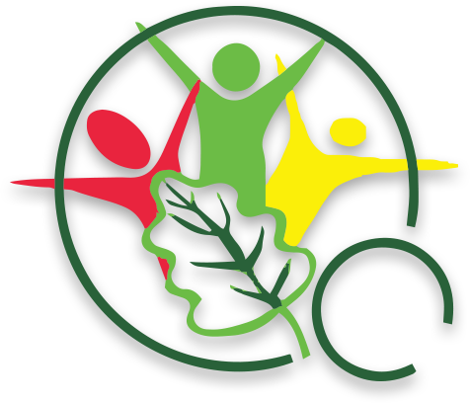

Science Experiment: The Water Cycle
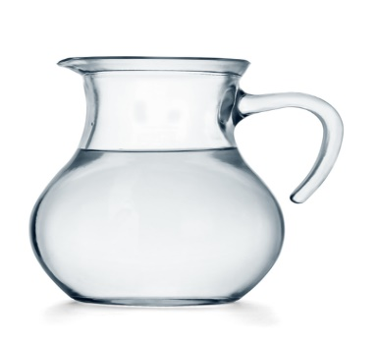
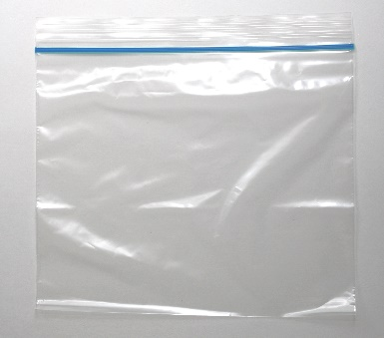
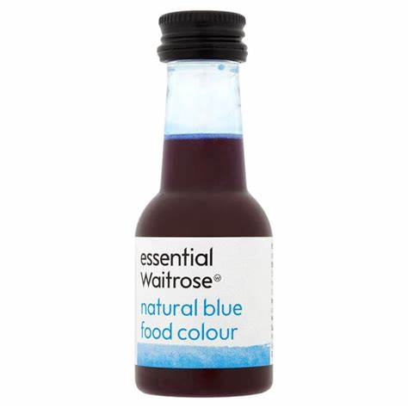
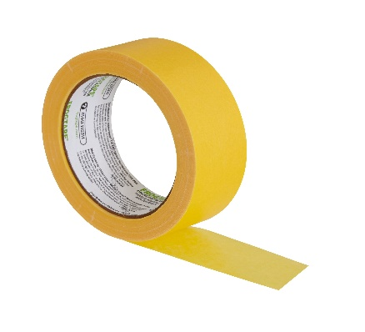
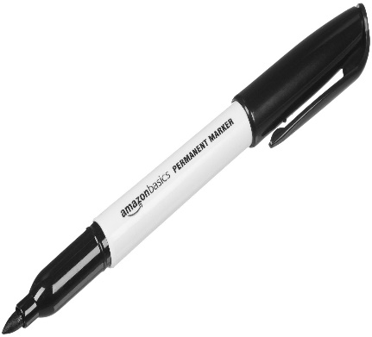
What is needed?

Objective:
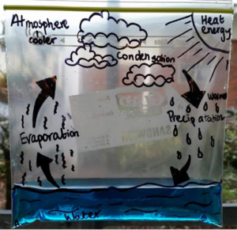
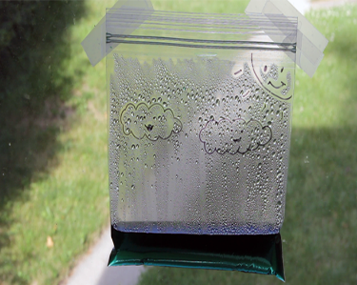
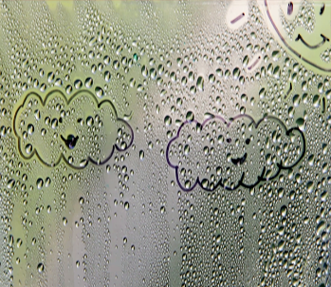
Label the plastic bag as shown (bottom right). Fill the plastic bag with a quarter (1/4) of water and add 2-3 drops of blue food colouring. Seal the bag tightly. Use tape and stick the sealed plastic bag to a window in your house. Come back in 1 hour and look at the bag. There will be changes to the bag. Leave the bag for another hour and then come back. Water droplets and condensation will form in the bag.

