Sharing learning with families

Dear ___________________,

As a school we are working on improving how we communicate with families about their children’s learning. Would you and your family like to receive pictures, video and scans of some of your child’s school activities?
To do this we ask you to agree to school sharing information with you using the school’s Seesaw.me account and app.
You will be asked to make use of the application Seesaw (information sent with this letter) on an Apple, Android, Chrome or Amazon device, or using the seesaw.me website.
Your child’s information will be kept and used in line with Data Protection Regulation policy and Privacy Notice, and only used in the ways you have agreed to on the permission form.
There is no charge for using Seesaw.
Please would you give by your permission for this by ticking, signing and returning the enclosed permission sheet?
If you would like more information, please contact your class teacher.

Yours sincerely

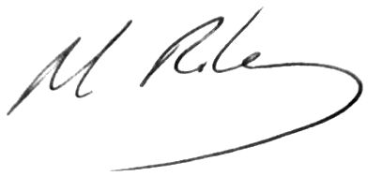
Deputy Head Teacher


Seesaw is a simple way for teachers and pupils to record and share what's happening in the classroom.

Each pupil gets their own journal for photos, videos, drawings, or notes.

When there are new Seesaw posts, families can be notified via app notification, email or SMS.

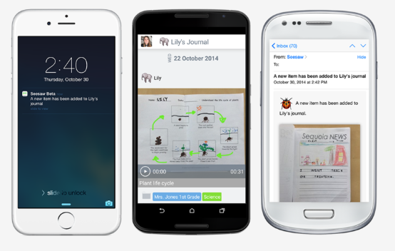

Families are only notified about their own child’s work, and all data is safe and secure.




Permission for information sharing using Seesaw.me

I give permission that teachers and class teams can:
(Please tick )
- Upload photos, video and audio to Seesaw for you to view.

- I agree not to redistribute images on social media.

- I take responsibility for the access code.

My child/young person’s name: __________________________________________
Signed: __________________________________________

Your name: __________________________________________

Date: __________________________________________

