Snow Bear: A Winter Sensory Adventure

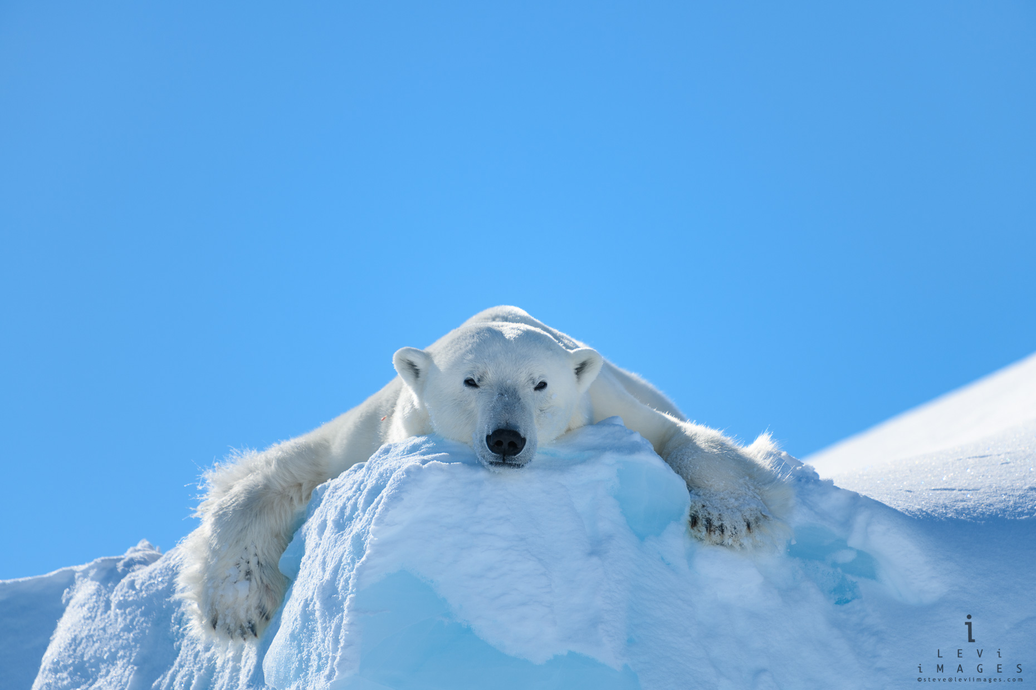

Text  Hi there, I’m Snow Bear. I’m looking for food. Excuse me, I’m hungry, I don’t mean to be rude.  I have to go hunting far out on the ice. Walking for miles to find something nice.  No brollies or wellies, I just have my fur. It keeps out the cold, can you feel it? Brrrr!  The ice just keeps melting, less snow on the ground. It just keeps on dripping, no food to be found.  I swim and I swim through the sea deep and blue.  Hoping my dreams of food will come true.  Finally, I spot it, a shimmering fish. A slinky, shiny fish making a splash.  Squishy and fishy my favourite treat. But I wish I could find more food to eat.  Now I have food to take to my family. But I have a long way to walk back to safety!  Now we wave goodbye to our friend Snow Bear. We are leaving behind the cold Arctic air. The planet is changing we hope that you care. | Prop  A soft toy polar bear or regular bear wrapped in a white blanket or make a face of a bear using paper and cotton wool.  A drum or shaker to bang. Or a bag of old cereal to crunch.  Fake fur, a fleece or fleecy hat.  Ice cubes in a tray of water.  …Turn lights off here…  and put disco lights, projectors or torches on.  Disco lights, projectors, blue lights or torches.  A toy fish, plasticine fish or fish shape cut out of foil.  Fish food or a plasticine fish.  Turn lights on here…  A drum or shaker to bang. Or a bag of old cereal to crunch.  Turn lights back on. Soft toy polar bear or polar bear face. | Action  Feel the bear’s face, eyes, ears, leathery nose/paws and soft white fur.  Bang the drum like the steady foot-steps of a polar bear or crunch the cereal. Make foot-steps on the learner’s arms or legs.  Feel the soft fur, or be wrapped in a fleecy blanket. Open the window or blow a fan to make it cold!  Try to grasp the ice cubes as they melt in the water. Pour the water through pourers to create a dripping sound.  Follow the moving lights (like fish in the water).  Watch the fish jump in and out of the water. Try to grasp the fish and feel it’s slippery scales.  Smell the fish food or feel the squishy plasticine fish.  Bang the drum like the steady foot-steps of a polar bear or crunch the cereal.  Make foot-steps on the learner’s arms or legs.  Feel the bear’s face again and stroke it’s fur. Wave goodbye.

