The Blue Abyss Sensory Story

Play this sound track in the background if you can. You may need to play it twice.

https://www.youtube.com/watch?v=9rXgKK3s1wE

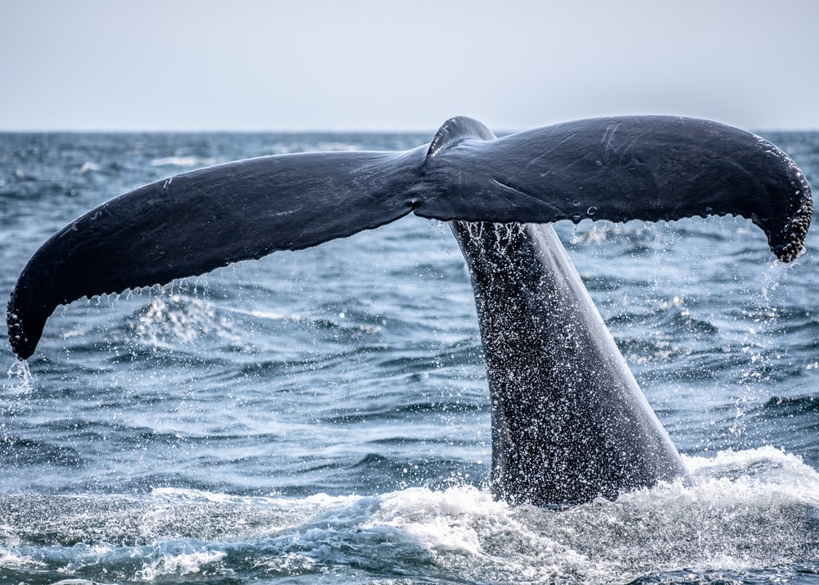

Text  This is a beach with water and sand. Can you feel grains rough in your hand?  This shell was washed up, hold it up to your ear. The wind or the sea, what can you hear?  There in the distance, a sea creatures’ tail! Can you feel the bumpy skin of the whale?  She swims next to you, with her baby cub. Can you hear the puffs of air, as they rise up?  The water is clear and the water is bright. Can you see the bubbles shining in the light?  Deep down in the sea an Octopus swims. Watch as it curls and stretches 8 rubbery limbs.  Now the sun is going down, soon it will be dark. Listen to the seagulls and watch out for the...SHARK! | Prop  Sand.  Large or small shells.  A piece of ridged card board in the shape of a Whale’s tail.  Empty washing up bottle.  Bubbles from washing up liquid or blowing bubbles.  Bubble wrap cut into strips  Lights off. Use hands for the shark. | Action  Sweep fingers through sand / feel sand on feet  Hold and explore shells / hold a large shell to your ear  Feel and explore the ridges and bumps of the Whale’s tale.  Squeeze the empty bottle so puffs of air come out. Feel the puffs on hand or face.  Blow bubbles into the air, follow and catch them!  Feel the Octopus’s limbs. Count to 8 as you feel each one. Get wrapped up in them!  Turn lights out and move hands like a shark’s fin through water. Make ‘duh dah duh dah’ sound effect. Then ‘snap’ both hands together.

