The Diwali Story / The Story of Rama and Sita

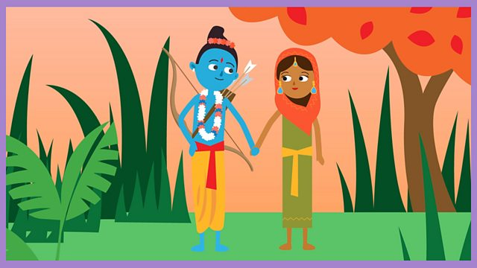

Text  Rama and Sita fled their Kingdom to find safety in the forest.  They clung together, in love.  After some time, Ravana the 10 headed demon, noticed Sita and wanted her for his own.  Ravana sent a golden deer to tempt Sita into the darker, wilder parts of the forest.  Sita wanted the golden deer so Rama went off to catch it.  Whilst Rama was hunting, Ravana captured Sita and flew her to his island of Lanka.  Rama asked his friend Hanuman the monkey to help him rescue Sita. Hanuman can make himself big or small.  After a fierce battle, Rama and Hanuman rescued Sita.  Rama and Sita travelled back home guided by the twinkling Diwali lights. | Prop  A branch with leaves on it.  A blanket – the heavier the better.  A paper plate with buttons for eyes and a nose and string for a mouth (on both sides).  A branch with leaves on it / an umbrella with leaves and black and green material hanging from it.  Torch or fairy lights.  Cardboard cut-out of a golder deer attached to thread or string / cuddly toy.  A fan or a way to move the listener around to feel air on their skin  Monkey noises  Tea spoons and a saucepan  Tea lights or fairy lights | Action  Hide behind the branches and rustle them, then allow for feeling on the leaves / stroking the face and arms or crumpling with fingers.  Cover in the blanket or hug or squeeze shoulders and arms (providing propreocepive input – awareness of body in space)  Show the demon by flipping the plate round and round and allowing for the feeling of his eyes, nose and mouth, 10 times!  Make the room dark and shine a light through the leaves / put the umbrella above the listener and immerse them in the dark forest / use light to illuminate the forest.  Move the golden deer around to be tracked / shine a light on it to make it shine  Use the fan on the skin or allow the listener ‘to fly’ inside/outside so they can feel movement and the air on their skin (providing vestibular input)  Make small monkey noises and loud monkey noises with actions or toys / play recordings of monkey noises / allow for tracking of the noises.  Drop spoons into the saucepan to make the sound of clinking swords.  Make the room dark and show a path of lights or circle the listener in lights.

